Transportation
Location of Airports：
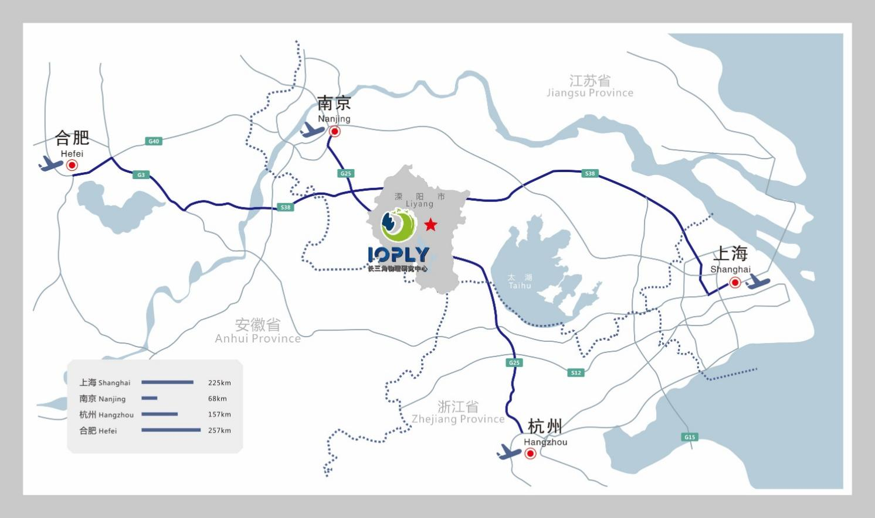

Location of Accommodations：
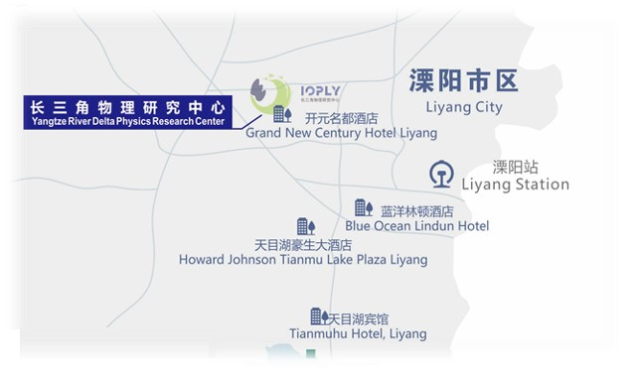
For International Participants：

Route 1(recommend)：Liyang High-Speed Railway Station — Corresponding Hotels
A. Free Shuttle buses are available between Liyang Railway Station and corresponding hotels during 9:00-21:00 on August 6
B. Take a taxi to your hotels，no more than 50 RMB

Route 2 (recommend)：Nanjing Lukou International Airport — Corresponding Hotels
A. Free Shuttle buses are available between Nanjing Lukou International Airport and corresponding hotels during 9:00-21:00 on August 6
B. Airport buses from Nanjing Lukou International Airport to Liyang Terminal are available on August 6 (The ticket price is 60 RMB), then take a taxi to your hotels or to Liyang Railway Station where you can take shuttle buses we arranged to hotels.
The round-trip timetable from Nanjing Lukou International Airport to Liyang Terminal is shown as follows:
Departure time of Nanjing Lukou International Airport：10：30、12：00、13：45、15：30、17：15、19：00、20：45、22：30。
Departure time of Liyang Terminal：05：50、7：00、8：30、10：30、12：30、14：00、16：00、18：00。
C. Take the subway Line S1 to Nanjingnan Railway Station, then transfer to high-speed rail from Nanjingnan Railway Station to Liyang Railway Station, then take shuttle buses or a taxi to your hotels
D. Take a taxi to Nanjingnan Railway Station, then transfer to high-speed rail from Nanjingnan Railway Station to Liyang Railway Station, then take shuttle buses or a taxi to your hotels
E. About 90 km and 90 minutes’ drive (taxi fee should be around 230 RMB) It is recommended to take the airport shuttle buses, due to language issues, it may be difficult for international passengers to the destinations by taxi.

Route 3：Shanghai Hongqiao International Airport — Liyang Railway Station
A. Take the subway Line 2 to Shanghai Hongqiao Railway Station, then transfer to high-speed rail from Shanghai Hongqiao Railway Station to Liyang Railway Station
B. About 235 km and 3 hours’ drive (taxi fee should be around 1200 RMB)

Route 4：Shanghai Pudong International Airport — Liyang Railway Station
A. Take the subway Line 2 from Shanghai Pudong International Airport to Shanghai Hongqiao Railway Station, then transfer to high-speed rail from Shanghai Hongqiao Railway Station to Liyang Railway Station
B. Take a taxi to Shanghai Hongqiao Railway Station, then transfer to high-speed rail from Shanghai Hongqiao Railway Station to Liyang Railway Station
C. About 290 km and 3.5 hours’ drive (taxi fee should be around 1500 RMB)

Route 5：Hangzhou Xiaoshan International Airport — Liyang Railway Station
A. Take the subway Line 19 from Hangzhou Xiaoshan International Airport to Hangzhoudong Railway Station, then transfer to high-speed rail from Hangzhoudong Railway Station to Liyang Railway Station
B. Take a taxi to Hangzhou Railway Station, then transfer to high-speed rail from Hangzhou Railway Station to Liyang Railway Station
C. About 205 km and 2.5 hours’ drive ( taxi fee should be around 1000 RMB)

Notes:
The Organizing Committee will arrange shuttle buses in Nanjing Lukou International Airport and Liyang Railway Station to the designated hotels. Participants are suggested to arriving at Nanjing Lukou International Airport or Liyang Railway Station. No shuttle buses will be arranged in other airports and stations. In case of special circumstances, please contact us in time.

